**Name:__________________________________________________**

**Worksheet for BIOB 375**

**Problem #1. Below is a histogram of tendril lengths from a pea population. We use histograms (frequency distributions) like this to determine if a given trait is qualitative or quantitative. What do you say based on this graph?**

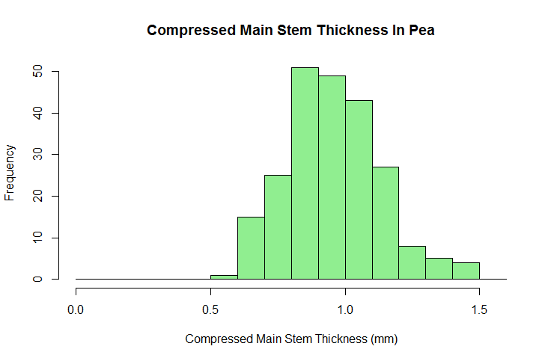

**Problem #2.**

**True or false: For quantitative traits, you can have many different genotypes that produce the same phenotype.**

**Problem #3.**

**A meristic characteristic is a quantitative characteristic that is measured in __________________**

**__________________________________________________________________________________________________**

**Problem #4.**

**Suppose the variance around the mean for each of the below distributions is 25. What is the standard deviation?**

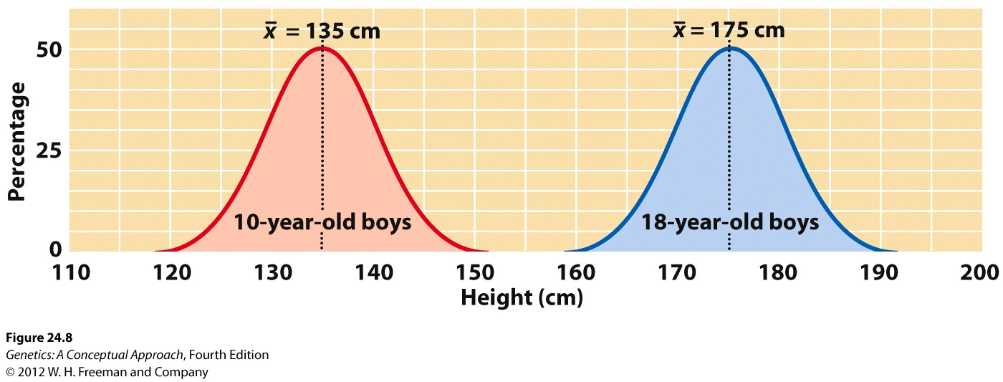

**Problem #5**

**What is the probability that you would have an 18 year old boy that is between 175 and 185 cm tall given the standard deviation you calculated above.**

*Hint. Remember that 95% of observations fall within 2 standard deviations of the mean and that that probability includes both sides of the mean.*

**Problem #6**

**Chicken body weight and egg production have a correlation coefficient of -.17. What does this mean? Why do you think the correlation is negative?**

**Problem #7**

**Suppose that phenotypic variability due to genetics is 20 cm for a certain population of 18 year old boys, and that variability due to the additive effects of alleles is 15 cm. Total variability is 30 cm. What is the broad sense and narrow sense heritability for this trait? What is the proportion of variance due to the environment?**

**Problem #8. Selection**

**What is artificial selection (recurrent selection)?**

**Why is it important in crop breeding?**

**Why will the response to selection often level off over time?**

**Problem #9**

**A recent ad for a wheat breeder position at Monsanto Corporation listed the following duty. “Manage wheat yield trials at 32 field sites across Montana.” Why do you think that Monsanto required their wheat breeders to have yield trials at 32 different widespread locations across Montana (short answer).**

**__________________________________________________________________________________________________**

**Problem #10**

**Define the term QTL.**

**Problem #11**

**Linked markers segregate with the gene of interest. Why do we want a genetic marker that is closely linked to the gene of interest?**

**Problem #12.**

**Suppose we know all the 5 QTL’S that control yield in apple trees. Would it be more efficient to do selection by just selecting high yielding apple trees in a population or by using marker assisted selection to select individuals with desirable characteristics? Why?**

**Problem #13**

**To date, the exact location of the Fw gene on Linkage group 3 in pea, which confers resistance to Fusarium Wilt (an economically important disease in pea) has not been located. Our closest genetic marker named THO is approximately .5 to 1 genetic map units away from the gene. Given that one map unit equals 3 million base pairs and that the gene could be on either side of THO, we have the location of the Fw gene narrowed down to a location spanning approximately how many base pairs.**

**Problem #14**

**How does Linkage allow us to use genetic markers to do QTL mapping and then marker assisted selection?**

**Problem #15**

**A breeder is trying to develop a marker to predict disease resistance in pea. A cross is made between two parents who differ in disease resistance. 100 progeny have been selfed for many generations (homozygous) and have the following characteristics.**

3 have disease resistance and have allele A for the marker.

46 have disease resistance and have allele B for the marker.

49 are susceptible and have allele A for the marker.

2 are susceptible and have allele B for the marker.

Is there linkage between the disease resistance gene and the marker?

If so, how many map units are we away from the gene?

What is the physical distance in base pairs of DNA if there is linkage (assuming 3 million base pairs per map unit)?

**If there is time- calculate whether there is linkage between the below markers.**

